Experiment – 5

Create a simple cloud software application for Library book reservation system for SIMATS library using any Cloud Service Provider to demonstrate SaaS.
AIM:
To design and deploy a Library Book Reservation System for SIMATS Library as a SaaS application using Zoho Creator.
PROCEDURE:
1.Log in to Zoho Creator with a valid account and initiate the system development process by creating a new application from scratch, allowing full customization of the library management structure.
2.Develop a Book Details form to systematically record essential information such as book title, author, category, identification number, and current availability status to ensure accurate inventory management.
3.Create a Member Details form to maintain comprehensive records of students and staff, including their names, contact information, membership IDs, and other relevant details required for borrowing books.
4.Design a Book Reservation or Issue Details form and integrate it with both the Book Details and Member Details forms using lookup fields, thereby establishing a relational connection between members and the books they borrow or reserve.
5.Configure automated workflows within the application to update book availability status when a book is issued or returned and to calculate and manage due dates effectively.
6.Publish and deploy the completed application as a cloud-based service, enabling authorized library users to access and manage records online.
7.After completing these configurations and deployment steps, the cloud-based library management software is successfully developed and made operational.

IMPLEMENTATION:

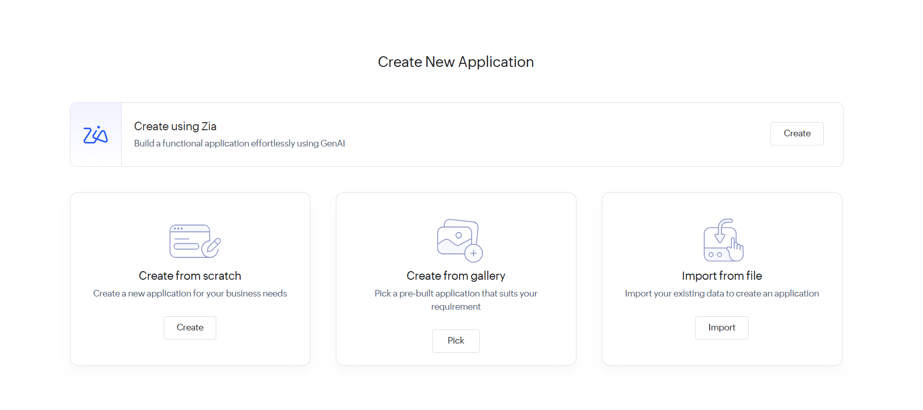

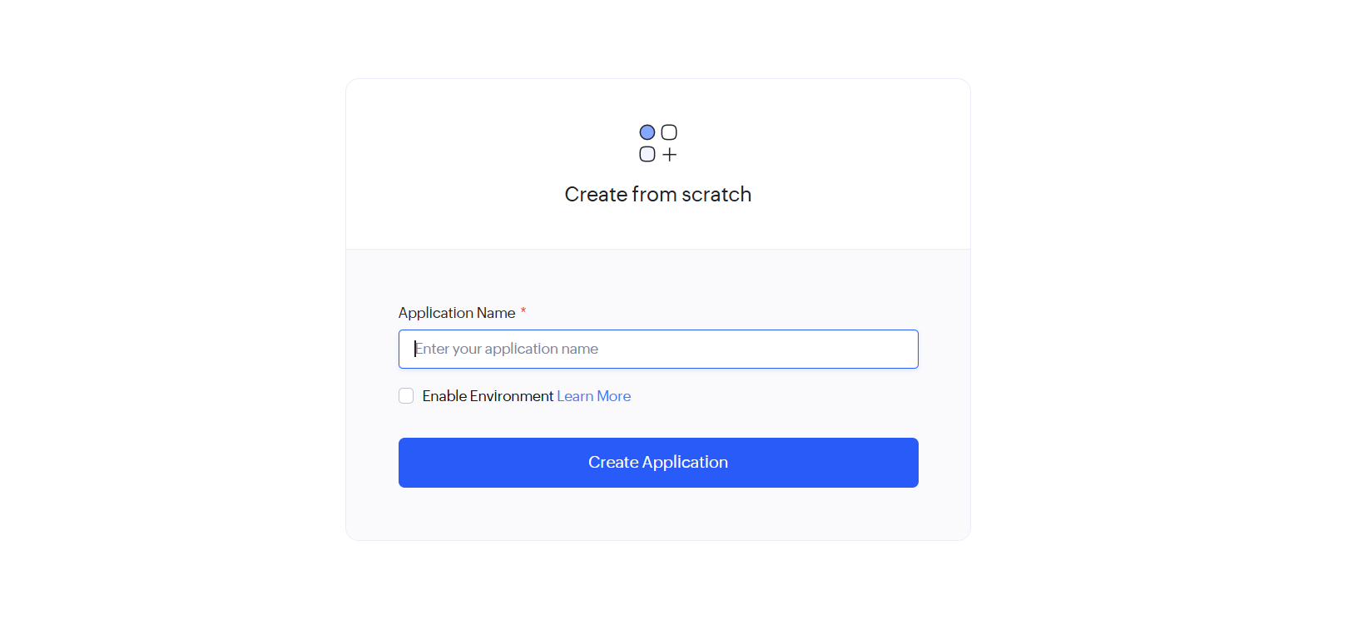

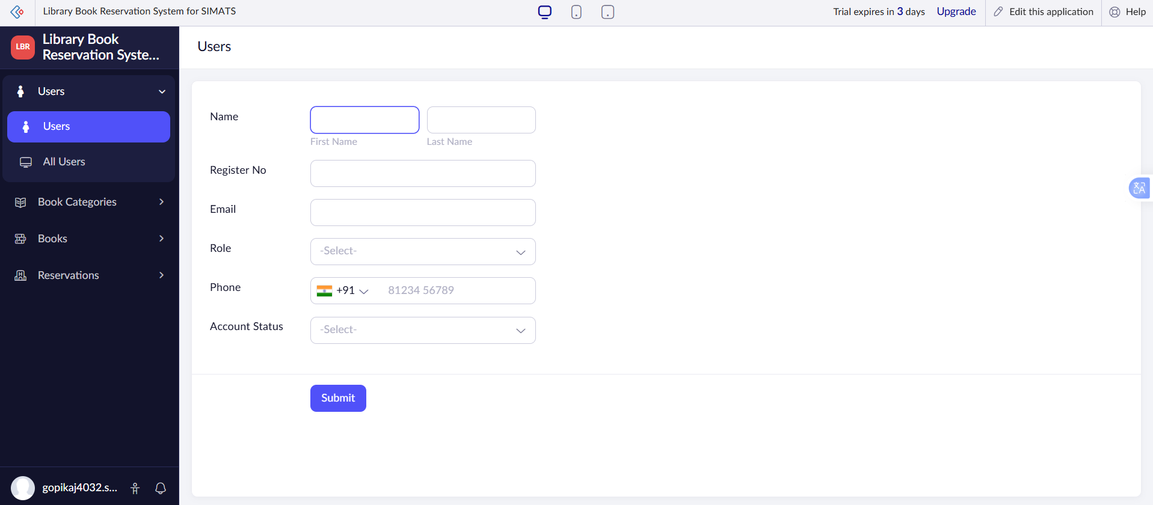
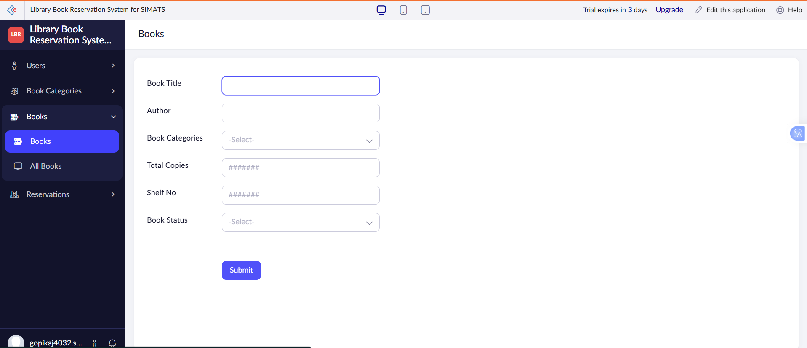

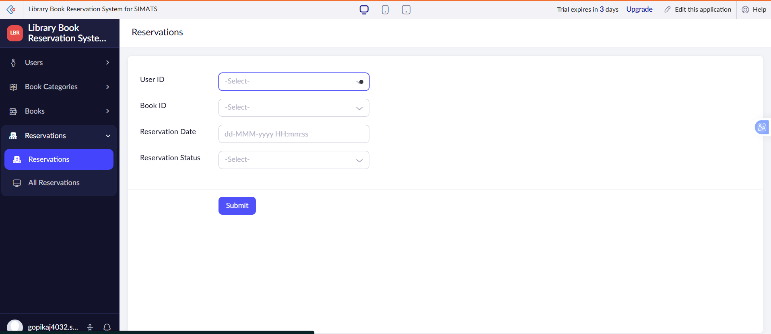

RESULT:
A SIMATS Library Book Reservation System is successfully implemented as a SaaS application, enabling efficient online book reservation and management.

